Phys 135A College Physics I
Activity 3: The Relationship between Distance, Velocity, and Acceleration in Kinematics Equations

Investigation 1: A car passes by the 5.0-m mark from the origin and travels away in the positive direction at a speed of 2.0 m/s with zero acceleration.

In an Excel spreadsheet,

- Calculate the velocity and position of this car for the next 10 seconds (include t = 0) in Excel using the formulas you learned in the lecture.

- Plot Velocity-Time and Distance-Time graphs for this car separately. Find the slope of the Distance-Time graph; compare it with the initial velocity given.

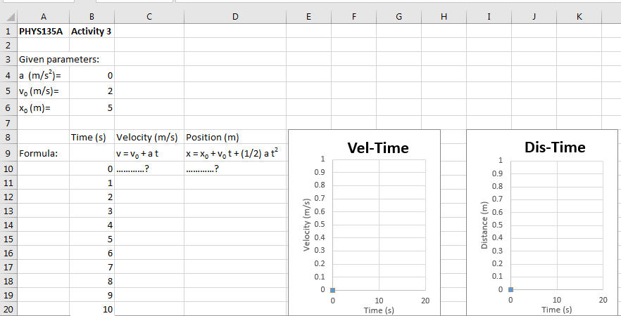

Investigation 2: A car passes by the 5.0-m mark from the origin and travels away in the negative direction at a speed of 2.0 m/s with zero acceleration. In an Excel spreadsheet,

1- Calculate the velocity and position of this car for the next 10 seconds (include t =0) using the formulas you learned in the last lecture.

- Plot Velocity-Time and Distance-Time graphs for this car separately. Find the slope of the Distance-Time graph; compare it with the initial velocity given.

Investigation 3: A car passes by the 5.0-m mark from the origin and travels away in the positive direction at a speed of 2.0 m/s with an acceleration of +1.0 m/s². In an Excel spreadsheet,

1- Calculate the velocity and position of this car for the next 10 seconds (include t =0) using the formulas you learned in the last lecture.

2- Plot Velocity-Time and Distance-Time graphs for this car separately. Find the slope of the Velocity-Time graph. What does it correspond to?

3- In the Distance-Time graph; fit a quadratic form to it, and interpret every parameter in the equation displayed after the fitting.

Investigation 4: A car starts at 5.0-m mark from the origin and travels away in the positive direction at a speed of 2.0 m/s but with an acceleration of
-1.0 m/s². In an Excel spreadsheet,

1- Calculate the velocity and position of this car for the next 10 seconds (include t =0) using the formulas you learned in the last lecture.

2- Plot Velocity-Time and Distance-Time graphs for this car separately. Find the slope of the Velocity-Time graph. What does it correspond to?

3- In the Distance-Time graph; fit a quadratic form to it, and interpret every parameter in the equation displayed after the fitting.

